PHP PDO Assignment

1. Create a form to insert First name, Last name, email id and contact no. Email id must be unique across the table. Validation must on DB and code level.
Ans :-
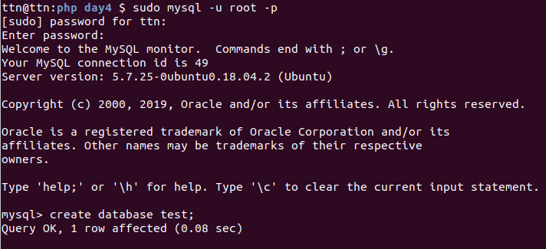
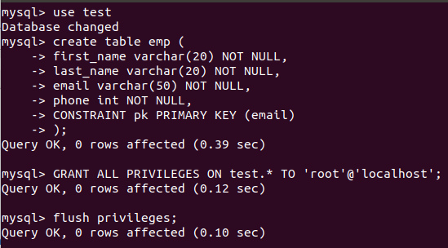
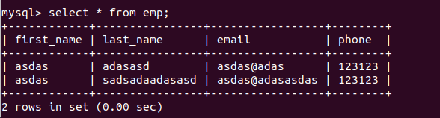

2. Create a form to search records by name, email and contact number. It should show matching results.
Ans :-
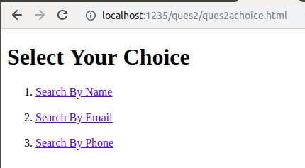

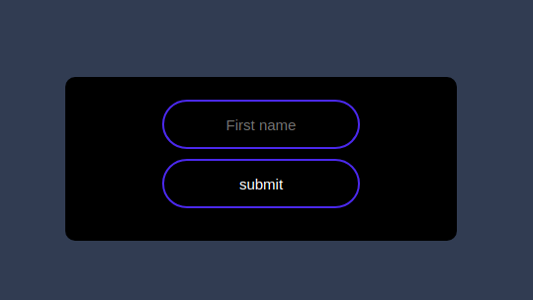

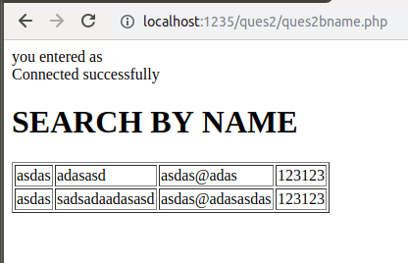

Similar outputs are for search by phone and email so i am not including them.

